Abstract submission – TAP and S&E conference 2023

Please fill in this form and submit together with the abstract! (* = mandatory)

*Abstract title:

*Authors:

*Corresponding author:

*E-mail of corresponding author:

Preferred presentation mode (mark with an X): …… Oral …… Poster

I intend to attend the following sessions (mark with one or several X):
…… TAP …… Joint TAP&SE ……. S&E

Additional comments:

Instructions for abstract preparation for TAP&SE 2023

J.L. First¹, P.L. Second² and J.C. Third²

¹Department of Transportation, University of Somewhere, City, Region, Postcode, Country
²Department of Chemical Engineering, University of Elsewhere, City, Region, Postcode, Country
Keywords: first, second, third, fourth.
Presenting author email: j.first@somewhere.edu

The abstract should be in double column (like this example) and strictly limited to ONE page long. Use A4 page set-up and make all margins (top, bottom, left, right) 20 mm wide. Start typing text about 7cm from the top of the page. Use 10 pt Times New Roman font (except for the title which should be in 12 pt bold and in sentence case). Centre the title, the authors’ names, the addresses, and keywords and contact email address. Please compose a title that clearly and succinctly describes the content of your work, in order to maximise its impact.
Start each paragraph, except the first, with an indent. Justify the body of the text both left and right. Do not use page numbers. Uniformity of abstract style makes the work much easier to digest! Keywords are there to draw attention to your abstract, and to help the organisers allocate the presentation to the most appropriate session.
Use clear English to write your abstract, with an emphasis on describing what is new and why it should attract the attention of the audience.
Figures can be in colour or in black and white. Ensure that Figures and Tables have a caption and that they are numbered consecutively.

Table 1. Comparison between theoretical predictions and experimental measurements.
Month | Measured density (μg/m3) | Predicted density (μg/m3)
January | 0.4 | 121
June | 2.4 | 1.528×10⁴

References should be made in the style (Dickenson, 2005), Marr and Morrissey (2010) or as Curtis et al (1996). Examples of references are shown below. Leave a blank line above the list of references, and also above the acknowledgements.
Section headings can be used, but they do take up valuable space: the same can be said of equations.

Abstract review
The abstracts will be reviewed by the TAP&SE 2023 Scientific Committee. Abstracts which do not fulfil the standards will be rejected. Please avoid submitting abstracts containing only future results.
The abstract should be submitted in both Word and pdf format via email to tapase@ivl.se no later than 15 February 2023.

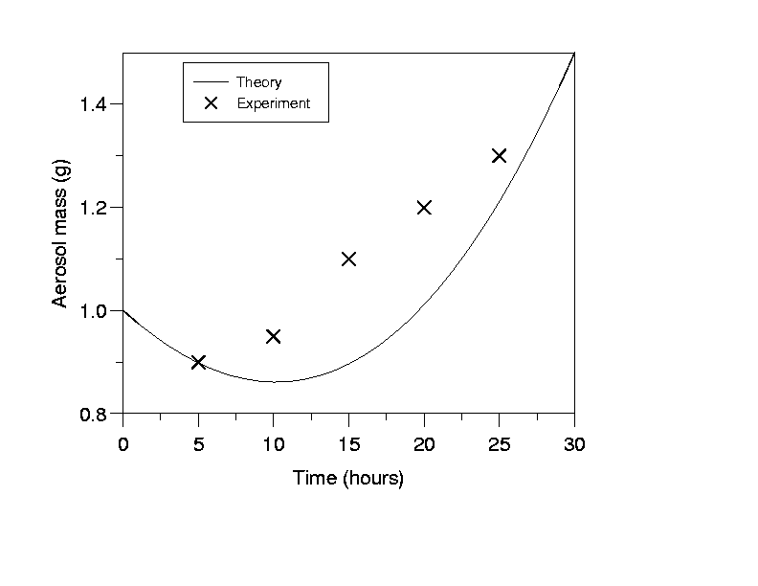

Figure 1. This is a comparison between theory and experimental data.

This work was supported by the xxxx fund.

Curtis, I., Hook, P., Morris, S. and Sumner, B. (1996) Proc. 2nd Int. Conf. on Aerosols in the Atmosphere, World Scientific.
Dickenson, B. (2005) Acoustic fragmentation of aerosol agglomerates, Manchester University Press.
Marr, J. and Morrissey, S. (2010) Phys. Rev. Lett. 210, 123-126.

